**Acropolis Institute Of Technology And Research,**

**Indore (M.P.)**



**Subject – Database Management System (DBMS)**

**(CY-405)**

Name – Prakhar Jain

Enrollment No. - 0827CY221043

Branch - CS(Cyber Security)

Semester - 4th  (2nd year)

Submitted To – Mrs. Nidhi Nigam Ma’am

**Index**

|  |  |  |  |  |
| --- | --- | --- | --- | --- |
| **Sr. No.** | **Experiment** | **Date of Exp.** | **Date of sub.** | **Grade** |
| 1. | To study DBMS and RDBMS, its characteristic comparisons and study of popular DB software. | 11/03/24 | 18/03/24 |  |
|  |  |  |  |  |
|  |  |  |  |  |
|  |  |  |  |  |
|  |  |  |  |  |
|  |  |  |  |  |
|  |  |  |  |  |
|  |  |  |  |  |
|  |  |  |  |  |
|  |  |  |  |  |
|  |  |  |  |  |
|  |  |  |  |  |

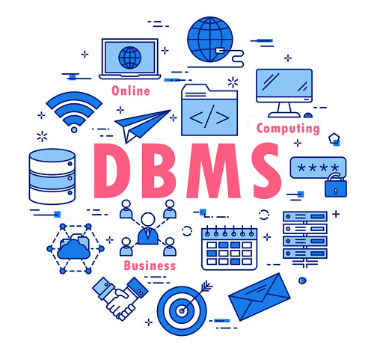

**Introduction to Databases**

**What is a Database?**

A database is a structured collection of data that is organized and managed to provide efficient retrieval and modification. It serves as a central storage location for data used by multiple applications or users.

**Types of Databases**

Relational databases: Organize data into tables with rows and columns, with relationships defined between tables.

NoSQL databases: Designed for storing and retrieving large volumes of unstructured or semi-structured data.

Object-oriented databases: Store data in the form of objects, along with their attributes and methods.

Others: Include graph databases for storing data in graph structures, and time-series databases for handling time-stamped data.

**Components of a Database System**

Data: Information stored in the database, organized into tables or other structures.

Database Management System (DBMS): Software that manages the database, including storing, retrieving, updating, and securing data.

Users and applications: Entities that interact with the database, such as users running queries or applications accessing and manipulating data.

## **Key Features of DBMS**

* Data Definition: Allows users to define the data structure and schema.
* Data Manipulation: Supports operations to insert, update, delete, and retrieve data.
* Data Security: Provides mechanisms for access control, authentication, and encryption.
* Data Independence: Separates data abstraction from physical storage, enabling flexibility.
* Concurrency Control: Manages concurrent access to ensure data consistency.
* Backup and Recovery: Provides tools for data backup and recovery in case of failures.
* Query Optimization: Optimizes query performance for efficient data retrieval.
* Transaction Management: Ensures ACID properties (Atomicity, Consistency, Isolation, Durability) for transactions.
* Scalability and Performance: Designed to handle large volumes of data and multiple users.
* Data Integrity: Enforces data integrity constraints to maintain data accuracy and consistency.

## **Applications of DBMS**

Management Systems (DBMS): Geographic Information Systems (GIS): DBMS is used to store and manage spatial data such as maps, satellite imagery, and geographic features. GIS applications use DBMS to store and retrieve spatial data for analysis and visualization.

Digital Libraries: DBMS is used to store and manage digital collections of books, articles, videos, and other resources. It allows for efficient storage, retrieval, and management of digital content.

Content Management Systems (CMS): DBMS is used in CMS to store and manage web content such as articles, images, and videos. It enables users to create, edit, and publish content on websites.

Data Warehousing: DBMS is used in data warehousing to store and manage large volumes of historical data from multiple sources. It allows for complex queries and analysis to support decision-making processes.

Scientific Research: DBMS is used in scientific research to store and manage experimental data, simulations, and research findings. It enables researchers to organize and analyze data for scientific discovery.

**TYPES OF DBMS**

There are various types of databases used for storing different varieties of data:

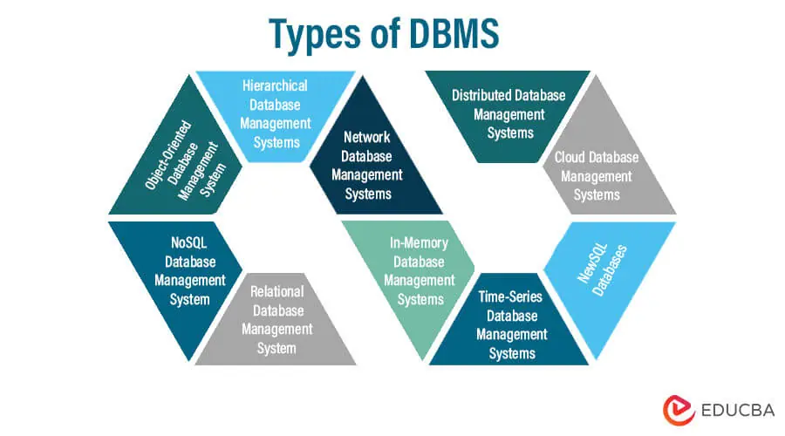

## **1) Centralized Database**

It is the type of database that stores data at a centralized database system. It comforts the users to access the stored data from different locations through several applications. These applications contain the authentication process to let users access data securely. An example of a Centralized database can be Central Library that carries a central database of each library in a college/university.

## **2) Distributed Database**

Unlike a centralized database system, in distributed systems, data is distributed among different database systems of an organization. These database systems are connected via communication links. Such links help the end-users to access the data easily. **Examples** of the Distributed database are Apache Cassandra, HBase, Ignite, etc.

## **3) Relational Database**

This database is based on the relational data model, which stores data in the form of rows(tuple) and columns(attributes), and together forms a table(relation). A relational database uses SQL for storing, manipulating, as well as maintaining the data. E.F. Codd invented the database in 1970. Each table in the database carries a key that makes the data unique from others. **Examples** of Relational databases are MySQL, Microsoft SQL Server, Oracle, etc.

## **4) NoSQL Database**

Non-SQL/Not Only SQL is a type of database that is used for storing a wide range of data sets. It is not a relational database as it stores data not only in tabular form but in several different ways. It came into existence when the demand for building modern applications increased. Thus, NoSQL presented a wide variety of database technologies in response to the demands. We can further divide a NoSQL database into the following four types:

## **5) Cloud Database**

A type of database where data is stored in a virtual environment and executes over the cloud computing platform. It provides users with various cloud computing services (SaaS, PaaS, IaaS, etc.) for accessing the database. There are numerous cloud platforms, but the best options are:

* Amazon Web Services(AWS)
* Microsoft Azure
* Kamatera
* PhonixNAP
* ScienceSoft
* Google Cloud SQL, etc.

## **6) Object-oriented Databases**

The type of database that uses the object-based data model approach for storing data in the database system. The data is represented and stored as objects which are similar to the objects used in the object-oriented programming language.

## **7) Hierarchical Databases**

It is the type of database that stores data in the form of parent-children relationship nodes. Here, it organizes data in a tree-like structure.

Data get stored in the form of records that are connected via links. Each child record in the tree will contain only one parent. On the other hand, each parent record can have multiple child records.

## **8) Network Databases**

It is the database that typically follows the network data model. Here, the representation of data is in the form of nodes connected via links between them. Unlike the hierarchical database, it allows each record to have multiple children and parent nodes to form a generalized graph structure.

**EXAMPLE OF DBMS..**

### 1. Oracle Database

### 2. MySQL Database

### 3. PostgreSQL Database

### 4. MongoDB

### 5. MS Access

### 6. Microsoft SQL Server

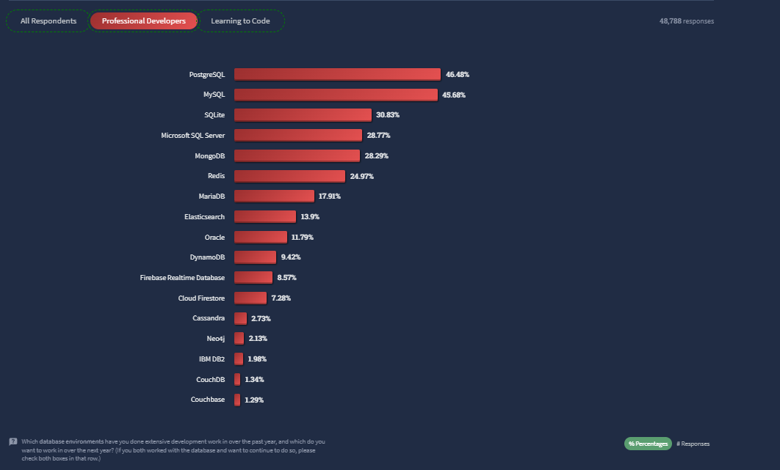

**What is MYSQL ?**

MySQL is an open-source relational database management system (RDBMS) that is widely used for managing structured data. It is developed, distributed, and supported by Oracle Corporation. MySQL is a popular choice for web applications, especially those running on the LAMP (Linux, Apache, MySQL, PHP/Perl/Python) stack, due to its ease of use, scalability, and performance

Some key features of MySQL include:

Relational Database: MySQL stores data in tables with rows and columns, and supports SQL (Structured Query Language) for querying and manipulating data.

Cross-Platform Support: MySQL is available for various operating systems, including Windows, Linux, macOS, and FreeBSD

Scalability: MySQL can handle large datasets and high traffic volumes, making it suitable for enterprise-level applications.

High Performance: MySQL is optimized for speed and efficiency, with features such as indexing, caching, and query optimization.

Security: MySQL offers robust security features, including access control, encryption, and auditing, to protect data from unauthorized access and breaches.

Replication and Clustering: MySQL supports replication, allowing data to be copied across multiple servers for scalability and fault tolerance. It also supports clustering for high availability.

## Community Support: MySQL has a large and active community of developers and users who contribute to its development and provide support through forums, documentation, and tutorials.

## **MySQL works in client/server or embedded systems**

MySQL Database is a client/server system that consists of a multithreaded SQL server that supports different back ends, several different client programs and libraries, administrative tools, and a wide range of application-programming interfaces (APIs). We also provide MySQL as an embedded multithreaded library that you can link into your application to get a smaller, faster, easier-to-manage standalone product.

**IS MYSQL IS OPEN SOURCE ?**

[Open source](https://developer.oracle.com/open-source/what-is-open-source/) means it’s possible for anyone to use and modify the software. Anybody can download MySQL software from the internet and use it without paying for it. You can also change its source code to suit your needs. MySQL software uses the [GNU General Public License](http://www.fsf.org/licenses/) (GPL) to define what you may and may not do with the software in different situations.

If you feel uncomfortable with the GNU GPL or need to embed MySQL code into a commercial application, you can buy a commercially licensed version from Oracle. See the [MySQL Licensing Information section](https://www.mysql.com/about/legal/) for more information.

**MySQL benefits..**

MySQL’s key benefits include

**Ease of use:** Developers can install MySQL in minutes, and the database is easy to manage.

**Reliability:** MySQL is one of the most mature and widely used databases. It has been tested in a wide variety of scenarios for more than 25 years, including by many of the world’s largest companies. Organizations depend on MySQL to run business-critical applications because of its reliability.

**Scalability:** MySQL scales to meet the demands of the most accessed applications. MySQL’s native replication architecture enables organizations such as Facebook to scale applications to support billions of users.

**Performance:** MySQL HeatWave is faster and less expensive as demonstrated by multiple standard industry benchmarks, including TPC-H, TPC-DS, and CH-benCHmark

**High availability:** MySQL delivers a complete set of native, fully integrated replication technologies for high availability and disaster recovery. For business-critical applications, and to meet service-level agreement commitments, customers can achieve

* Recovery point objective = 0 (zero data loss)
* Recovery time objective = seconds (automatic failover)

**Security:** [Data security](https://www.oracle.com/in/security/database-security/what-is-data-security/) entails protection and compliance with industry and government regulations, including the European Union General Data Protection Regulation, the Payment Card Industry Data Security Standard, the Health Insurance Portability and Accountability Act, and the Defense Information Systems Agency’s Security Technical Implementation Guides. MySQL Enterprise Edition provides advanced security features, including authentication/authorization, transparent data encryption, auditing, data masking, and a database firewall.

**Flexibility:** The MySQL Document Store gives users maximum flexibility in developing traditional SQL and NoSQL schema-free database applications. Developers can mix and match relational data and JSON documents in the same database and application.

**Comparison Between DBMS and RDBMS**

Data storage: DBMS stores data in various formats, while RDBMS stores data in tables with predefined schemas.

Data manipulation: DBMS uses navigational or procedural languages, while RDBMS uses SQL for data manipulation.

Query language: DBMS may use different query languages, while RDBMS primarily uses SQL.

Scalability: RDBMS may have limitations in scaling to handle large volumes of data compared to DBMS.

ACID properties: RDBMS ensures ACID (Atomicity, Consistency, Isolation, Durability) properties for transactions, which may not be guaranteed in all DBMS.

**Study of Latest Software of DBMS**

**Overview of Modern DBMS Software**

Trends in database technology: Includes the shift towards cloud-based databases, the rise of NoSQL databases for handling unstructured data, and the use of in-memory databases for faster performance.

Introduction to cloud-based databases: Databases hosted and managed in the cloud, offering scalability, high availability, and reduced maintenance overhead.

Examples of Latest DBMS Software

MongoDB: A popular NoSQL database known for its flexibility and scalability.

PostgreSQL: An open-source RDBMS known for its advanced features and standards compliance.

Oracle Database: A comprehensive RDBMS with a wide range of enterprise features.

Microsoft SQL Server: A relational database management system developed by Microsoft.

MySQL: An open-source RDBMS that is widely used for web applications.

**Comparison of Latest DBMS Software**

Performance: Each database software has its own performance characteristics, depending on factors like data volume, query complexity, and hardware.

Scalability: Some databases are better suited for scaling horizontally (adding more servers), while others may scale better vertically (upgrading server hardware).

Security: Different databases offer various security features, such as encryption, access controls, and auditing capabilities.

Cost: The cost of using a database includes licensing fees, support costs, and hardware requirements, which can vary significantly between different software.